Final Report on

**SUDOKU GAME SOLVER**



Subject : Artificial Intelligence (INT 404)

Submitted to : Dr.Sukhvir kaur

Section : K18TS

Submitted By:

|  |  |  |  |
| --- | --- | --- | --- |
| S.No | Roll No. | REG.NO | NAME |
| 1 | 11 | 11802623 | Vishal singh |
| 2 | 12 | 11805680 | Nishanth |
|  |  |  |  |
|  |  |  |  |

:

1. Abstract of the project:

This project is “ SUDOKU GAME SOLVER”.which is to make a puzzle by the Artificial intelligence techniques.the aim of the project is to built a puzzle for sooving and understanding the puzzle.the puzzle is named as sudoku.which is a technique and a kind of game developed for making the intelligence sharp and make thinking power to an upgraded level.

2. About puzzle:

Solving Sudoku has been a challenging problem in the last decade. The purpose has been to develop more effective algorithm in order to reduce the computing time and utilize lower memory space. This essay develops an algorithm for solving Sudoku puzzle by using a method, called pencil-and-paper algorithm. This algorithm resembles human methods, i.e. it describes how a person tries to solve the puzzle by using certain techniques. Our ambition is to implement the pencil-and-paper algorithm by using these techniques. There are currently different variants of Sudoku such as 4X4 grids, 9X9 grids and 16X16 grids. This work is focused on classic and regular Sudoku of 9X9 board, and then a comparison is performed between the paper-and-pencil method and Brute force algorithm

3. Implementation:

Implementation is done by using GUI in python.where the code consists of some artificial intelligence concpts.

CODE

import pprint

def solve(bo):

find=find_empty(bo)

if find:

row,col=find

else:

return True

for i in range(1,10):

if valid(bo,(row,col),i):

bo[row][col]=i

if solve(bo):

return True

bo[row][col]=0

return False

def valid(bo,pos,num):

for i in range(0,len(bo)):

if bo[pos[0]][i] == num and pos[1] != i:

return False

for i in range(0,len(bo)):

if bo[i][pos[1]] == num and pos[1] != i:

return False

box_x=pos[1]//3

box_y=pos[0]//3

for i in range(box_y*3,box_y*3 + 3):

for j in range(box_x*3,box_x*3 + 3):

if bo[i][j] == num and (i,j) != pos:

return False

return True

def find_empty(bo):

for i in range(len(bo)):

for j in range(len(bo[0])):

if bo[i][j] == 0:

return(i,j)

return None

def print_board(bo):

for i in range(len(bo)):

if i %3 ==0 and i != 0:

print("-------------------")

for j in range(len(bo[0])):

if j%3 ==0:

print(" | ",end="")

if j ==8:

print(bo[i][j],end="\n")

else:

print(str(bo[i][j]) + " ",end="")

board = [

[7,8,0,4,0,0,1,2,0],

[6,0,0,0,7,5,0,0,9],

[0,0,0,6,0,1,0,7,8],

[0,0,7,0,4,0,2,6,0],

[0,0,1,0,5,0,9,3,0],

[9,0,4,0,6,0,0,0,5],

[0,7,0,3,0,0,0,1,2],

[1,2,0,0,0,7,4,0,0],

[0,4,9,2,0,6,0,0,7]

]

pp = pprint.PrettyPrinter(width=41, compact=True)

solve(board)

pp.pprint(board)

4. Output:

OUTPUT SCREENSHOTS

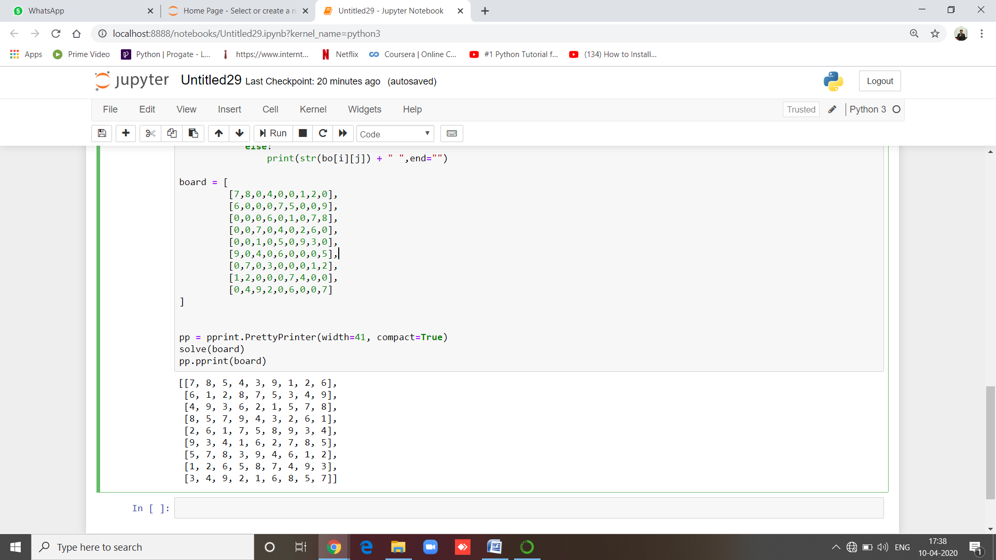

Note :

.

5. Team Responsibilities:

This project team comprised of two persons. The project has lot of applications to work on. The work is divided among the team members according to the number of applications it is dealing with. The work of team members is divided among the modules included in the project.

Team member 1:

Worked on the coding section in GUI using python. Modules were created and divided based on the no.of libraries used. Also worked for making the report and video presentation

Team member 2:

Invoking and shutting of the virtual assistant application.Interacting with web dusing webbrowser library to collect the required information about the request of user.GUI (Graphical User Interface) for the sudoku game solver

REFERENCES:

we have refered the many online platforms for puzzle solving and making techniques.